**Visualization System for Reverse Engineering Two Different Software Versions and Visually Identify the Changes in the Software at the Architecture Level**

**-By Rashi Goyal**

Table of Contents

1 INTRODUCTION 4

1.1 Purpose 4

1.2 Product 4

1.3 User 4

2 ARCHITECTURE 5

2.1 Principal Design Decisions 5

2.2 Main Architectural Style/Pattern Used 6

2.2.1 Reason for choosing Three Layered Architectural pattern 6

2.2.2 Benefits of using C2 architecture style 6

2.2.3 Other Styles/Patterns Considered 7

2.3 High-Level Architecture 7

2.3.1 Presentation Layer 7

2.3.2 Logic Layer 8

2.3.3 Data Layer 8

2.4 High level architecture diagram 10

2.5 Did you change your style/pattern since the last submission? Why or why not? 12

3 DETAIL DESIGN 12

3.1 Presentation Layer 12

3.1.1 DiffTool Component 12

3.1.2 User Interface Component 12

3.2 Logic Layer 14

3.2.1 UML Generating Component 14

3.2.2 XML Parser 16

3.2.3 Matrix Generating Component 17

3.2.4 Clustering Component 19

3.2.5 Topic Modelling Component 20

3.2.6 Mapping Component 22

3.2.7 Difference Finder Component 24

3.3 Data Layer 25

3.4 Connectors 26

3.4.1 C1 Connector 26

3.4.2 C2 Connector 27

3.4.3 C3 Connector 27

3.4.4 C4 Connector 27

3.4.5 C5 Connector 27

3.4.6 C6 Connector 28

4 IMPLEMENTATION 28

4.1 List of Built-from-Scratch Components 28

4.2 List of Of-the-shelf Components 28

4.3 Other OTS tools considered with unsuccessful results 29

5 MAINTENANCE STRATEGY 29

6 USER GUIDE 29

6.1 Minimum System Requirements: 29

6.2 Environment Setup: 29

6.2.1 Java 8 JDK Installation: 29

6.2.2 NetBeans 8.1 IDE Installation: 30

6.3 Downloading the Executables: 30

6.4 Step-by-Step Walkthrough on running the executables: 30

6.5 Steps in case Executables does not run 34

6.6 Step by Step Walkthrough the code: 35

7 FUTURE RELEASE 36

7.1 Functional Requirements that will be included in future Release 36

7.2 Non-Functional Requirement that will be included in future Release 37

8 REFLECTION 38

# INTRODUCTION

The document describes the architectural design of the proposed visualization tool that identifies the changes in the software architecture across two different versions of the software. It includes the rationale behind choosing the design pattern, the design decisions made based on the requirements of the system, high-level architecture and illustrates the functionalities of the system. It acts as a guideline, helping the development team to have a vision and build the system which is consistent with the requirements and the architecture.

## Purpose

This document gives an insight of the design description of the proposed system. It acts as a model to the software development team to build the system. It helps the team to have a vision and act towards it. This is essential because, as we develop the software one may face many challenges and the design document stays as a reference with which we can look back and make sure we are on the right path. The design document is accompanied with the architecture of the system that helps us provide the client with the detailed feature specifications. Hence, it is a medium of communication with the client and confirms we are in pace with each other.

## Product

This project is to plan, design, build and implement a visualization tool which will reverse engineer two different software versions and visually identify the changes in the architecture.

* The system will be capable of extracting source codes of different versions from the location specified by the user.
* It will then use a reverse engineering tool like NetBeans to generate the XML files from both the code files.
* These XML files will be passed as input to Matrix Generator which generates the similarity matrix and the similar clusters are formed using the Clustering Module.
* In parallel, the Document Extraction will get the input from the documentation on the web to perform topic modeling to search for the most emphasized keywords of the document.
* The clusters and the keywords from the document are mapped for similarities using the Mapping component and stored in the repository.
* These above steps are repeated for the other version and the result is stored. The Difference Finder tool pulls both the results and finds all the differences in the design of the two versions of the software and highlights all the differences.

## User

The intended user of the system is any organization or individual interested to find the difference between the architectural designs of their project's different versions. It is important to monitor and extract specific differences in the versions using logs and analyze it. This task is difficult to achieve manually as it is hard to identify the architectural design difference for large projects. This tool will help solve this issue by automating the process of extracting XMLs and comparing the differences after generating an intermediate mapping document.

# ARCHITECTURE

The principal design decisions were made on the functional requirements described as the product, along with the non-functional requirements specified by the project stipulation. The visualization system for reverse engineering two different software versions is composed of layered architecture combined with C2 architecture style.

**Architecture Style:** Layered architecture with C2 architectural style.

**Development Platform:** Java

**Frontend Development Tool:** Java swing

## Principal Design Decisions

The following are the principal design decisions made based on our requirements:

|  |  |  |  |  |  |  |
| --- | --- | --- | --- | --- | --- | --- |
|  | **REQUIREMNTS** |  |  | **DESIGN DECISION** |  |  |
|  |  |  |  |  |
|  | Scalability |  |  | Scalability has been ensured to efficiently handle growing amount of |  |  |
|  |  |  |  | data. The tool should be able to process at least 10K LOC and increase |  |  |
|  |  |  |  | to 100K and more LOC by Efficient use of memory. Different |  |  |
|  |  |  |  | components ensure that memory requirements do not keep on |  |  |
|  |  |  |  | growing indefinitely with growing size. |  |  |
|  | Performance Improvement | |  | Multithreading is used for improving the performance of the system. | |  |
|  |  |  |  | With increased data size, data flow will be delegated among different | |  |
|  |  |  |  | processors. | |  |
|  | Recoverability |  |  | Application logs will be created to ensure systems recoverability. In |  |  |
|  |  |  |  | case of failure, system can be recovered easily by identifying areas of |  |  |
|  |  |  |  | failure by using logs generated. |  |  |
|  |  |  |  |  |  |  |
|  | Reduce Processing Time | |  | To reduce processing time execution of Matrix generation and Topic | |  |
|  |  |  |  | Modeling will be carried out in parallel thus increasing the response | |  |
|  |  |  |  | time and performance of the system. | |  |
|  | Modularity |  |  | Modularity has been introduced that provided ease of component |  |  |
|  |  |  |  | replacement or redeployment in the system with minimal effect to the |  |  |
|  |  |  |  | system. |  |  |
|  | Low coupling | |  | Server has been divided among various logical components and each | |  |
|  |  |  |  | component performs it relevant functionality. Low coupling is | |  |
|  |  |  |  | enforced which provides maintainability, testability, reusability, and | |  |
|  |  |  |  | readability benefits. | |  |
|  | Visualization is intuitive |  |  | Visualization is intuitive, requiring minimal training time. System will |  |  |

|  |  |
| --- | --- |
|  | display all the visual differences using Java Swing Tool Kit which will |
|  | display visual differences between two version using different colors |
|  | scheme. |
| Multilanguage Support | For supporting multiple languages, system design is well abstracted |
|  | out from the input language. The system is initially using NetBeans |
|  | plugin but for supporting any language, the tool will have the ability to |
|  | switch with another plugin on user request. |
| Usability | The system will be made highly usable for the end user ensuring to |
|  | achieve quantified objectives with effectiveness and efficiency. |
| Performance Improvement | Storage will be used to store the output of all components and final |
|  | output of first version only. To overcome performance issues second |
|  | version of the code will be directly based from mapping component to |
|  | difference finder component. |
| Component Output | Output of each component would be preserved to be display in case of |
|  | request made by end user. |

## Main Architectural Style/Pattern Used

The main Architectural style used by the system is three layered Architectural style having following design layers:

* Presentation Layer
* Logic Layer
* Data layer

Each layer has different functionality, and they are developed and maintained as independent modules. A detailed description of the three layers are mentioned in 2.3

### Reason for choosing Three Layered Architectural pattern

This pattern was chosen over other patterns as it fulfills both the functional and the nonfunctional requirements of the product being developed. Three Layered Architectural pattern has following benefits:

* **Maintainability**- Each layer is independent of the other layers, changes/updates can be done without affecting the whole system.
* **Scalability**- Since layers are separated, scaling out the system is reasonably straightforward.
* **Flexibility** – Since each layer can be managed separately, flexibility is increased.
* **Performance** – Since Distribution of layers is over multiple stages, can improve fault tolerance and performance of the system.

### Benefits of using C2 architecture style

* **Flexibility:** Adding and updating new components to the system is easy.
* **Reliability:** Leveragingexisting components that have been carefully designed, implemented and verified.
* **Scalability:** C2 helps understanding operational constraints and the support of component interface granularity.
* Understandability, increasing the comprehensibility of complex systems using high level models.
* The C2 style provides for the development of distributed, dynamic applications by focusing on the structured handling of connectors to achieve layer independence.

### Other Styles/Patterns Considered

We considered following other Architectural design patterns while designing our system.

* We initially started with the Model View Controller (MVC) considering the requirements of our system. But as we implemented it, we realized that it was not best suited as it caused complications in design. Maintainability was difficult to achieve as the view and the model layers were tightly coupled. Changes in one layer would have affected the other layers causing instability to the system.
* Pipeline architecture illustrates the flow of data in and out of different components clearly but it requires more resources as compared to other architecture designs. Increased latency is observed as it is a linear architecture, i.e., every proceeding phase must wait for the input from the previous one. Our requirements were not being fulfilled using this pattern.
* Blackboard System did not fit our requirements completely.

**Hence, the layered architecture was selected as it satisfies all the requirements.**

## High-Level Architecture

Goal of High Level Architecture is to define a common simulation infrastructure to support interoperability and reuse of simulations. Using the C2 connectors, the requests flow up and notifications fall. Hence the Presentation Layer is at the bottom and the Data Layer at the top.

### Presentation Layer

The Presentation layer provides services for an application program to ensure effective communication between user and application program. It is the layer which handles user interaction from UI. It can be thought of as high-level set-up services for the application program or an interactive user.

* User interaction with the system is achieved by using presentation layer via user interface. The results of the user query will be displayed on the UI in the form of the architectural diagrams of two versions highlighting their differences.
* workflow starts with the User Interface component where fetching the code and document for finding out the version differences is initiated. The code fetched is transferred from interface to UML Generator via C2 connector.

### Logic Layer

This layer is the business layer which controls application functionality by performing detailed processing for all in an independent parallel fashion. It will perform the following tasks:

* This layer implements the Domain Model in a boundary-technology-neutral way. In other words, it doesn't depend on any particular UI or service interface-related technology, such as web libraries or windowing APIs.
* Main responsibilities of this layer are UML Generation from code, Matrix Generation, source code clustering and Topic modeling.
* UML Generator will generate the UML diagram and the intermediate result will be saved in the database through the connector buses in class diagram format. The output from UML Generator will be passed to XML Parser that will parse it to XML File. This XML file is used as an input for the Matrix generator which will produce a matrix, defining relationship between classes and methods/variables. The intermediate results from Matrix Generator will again be stored in database through C2 connector buses. The Clustering component will take the output of Matrix generator and will generate the clusters depending on the similarities which will be saved in the database to be used by another module. This step is repeated for both code versions to be compared.
* In parallel to UML Generator, Topic Modelling Component will use the document extracted from interface as input for Topic Modelling and the result of topic Modelling will be stored in the database via C2 connector buses.
* The Mapping component takes the results of Topic Modelling and Clustering components and produces a document with the mappings of all the topics from documentation with all the classes/methods. This result will be stored in database and another mapping for second version of code is generated and stored in Database too.
* Finally, both the files generated by mapping component are taken as input by the Difference Finder Component through connector buses. It will process these results to produce the final output i.e. visual differences between the two versions of the same software.
* The Final Output of the tool will be displayed on the user interface and will also be stored in the database via C2 Connectors.

### Data Layer

A data layer which handles all the data access related tasks mainly data storage and   retrieval. It helps collect more accurate analytics data, which in turn allows to better understand what users are doing on the application and where improvements can be implemented. Having a separate data layers improves scalability and performance.

* This layer will be responsible for storage and retrieval of all the output results that come from the logic layer.
* It will store all the intermediate results from logic layer along with the architecture diagrams of two versions of a Software.
* The difference finder tool can access those diagrams and highlight the changes and stores the result back in the database

### High level architecture diagram



## Did you change your style/pattern since the last submission? Why or why not?

No, we did not change the architectural style. We believe that this layered architecture will best fit the requirements. We have added the C2 style, as it is an indirect invocation style where the independent components exclusively communicate through message routing connectors. Layering is induced by the strict rules on connections between connectors and components. All components have defined top and bottom, where notifications flow downwards and requests goes upwards.

# DETAIL DESIGN

In this section, we provide the detailed description of the components and connectors used in the system.

## Presentation Layer

### DiffTool Component

**Purpose**

This class configure the components into C2 style architecture by creating instances of the Components, Connectors, and weld Connectors to Components and/or other Connectors.

**Rationale**

This component establish connection between components and connectors by wielding the component with connectors.

**Description**

When DiffTool calls start(), its super class calls each Component’s start() method. This makes the Components start listening to any Requests and Notifications that is generated by any of the components wielded with C2 connector.

**Required** **Interface**

None

**Provided Interface**

void start ()

### User Interface Component

**Purpose**

The user requests to visualize the differences between the architectural designs of their project's different versions through an interface (Graphical User Interface). Upon the request, this component initiates the process of fetching the code and user manual of the project.

**Rationale**

The User Interface Component is one of the key component of the system as it is the only component which interfaces with the users, take user input and show final output.

**Description**

It runs a trigger that initiates the process by fetching documentation and extracting code of two different versions of the specified application. This extracted data, serves as the input for the system and at the end of the process, the differences between two versions are displayed on the interface.

**Top Interface**

**Request**

The following requests are sent to UML generator and Topic Modeling components.

*protected Request topOutGetCode();*

*Request r = topOutGetCode();*

*send(r);*

***Description***

This method will request the UML generator to get the path of the code files. It will have following parameters:

*r.addParameter("FilePath", FilePath);*

***Parameters***

filePath: The path of its location in the local server.

***Exception***

DataNotFoundException: throws this exception when there is no data found

*protected Request topOutGetDocument();*

*Request r = topOutGetCode();*

*send(r);*

***Description***

This method requests the Topic Modeling to fetch for the documentation of the software.It will have following parameters:

*r.addParameter("FilePath", FilePath);*

***Parameters***

filePath: The path of its location in the local server ***Exception***

DataNotFoundException: throws this exception when there are no documents found

**Notification Handler**

This component will get notification from Topic Modelling and UML generator upon receiving the request from User Interface Component.The following method will handle the notification

*protected void handle(Notification n)*

This method will check the following parameters of notification objet

* Name of the Notification by n.name()
* n.hasParameter("AckValue")

**Bottom Interface**

There is no bottom interface for this presentation layer.

**Request Handler**

There is no request handler for this component because being the first component of the System it will not get any request from any component.

## Logic Layer

### UML Generating Component

**Purpose**

This component will generate a reverse engineered diagram i.e. a UML diagram from the given code. The UML diagram is in form of .cdg file.

**Rationale**

This is a very important component of the system as it provides the reverse engineered diagram in form of an cdg file of the code which will provide all the crucial and trivial details of the application like class names, variables, methods and their relations with each other.

**Description**

The code versions that are fetched by User Interface component serves as input for this component. It will generate the Reverse Engineered UML diagram using NetBeans plug-in and generate a .cdg file, which will further be converted into an xml file by xml parser component.

**Top Interface**

**Request**

The requests are sent to the XMLParser.

*protected Request* topOutGenerateXML *()*throws DataNotFoundException*;*

*Request r =* topOutGenerateXML *();*

*send(r);*

***Description***

This method will request the XML Parser to get file path of reverse engineered .cdg file and generate the XML from it using UML generator. It will have following parameters:

*r.addParameter("FilePath", FilePath);*

***Parameters***

filePath: The path of its location in the local server.

***Exception***

DataNotFoundException: throws this exception when there is no data found

**Notifications Handler**

It will handle the notification received by XML parser upon receiving request from UML generator. The following method will handle the notification

*protected void handle(Notification n)*

This method will check the following parameters of notification objet

* Name of the Notification by n.name()
* n.hasParameter("AckValue")

**Bottom Interface**

**Notification:**

It will notify the user interface upon successfully receiving the code. Following method will be used by this component to send notification.

*protected Notification CreateNotification()*

*Notification n = CreateNotification();*

*send(n);*

***Parameters:***

*Acknowledgement will be used as a parameter to this method.*

*n.addParameter("AckValue", "Succesfully Updated");*

**Request Handler:**

It receives the requests from the User Interface for fetching the code from the specified path. The request will be handled by the following method:

protected void handle(Request r)

***Description***

This method will scan through all the code and give basic relationships between classes.  
***Parameters***

protected void handle(Request r)

This method will check the following parameters of notification objet

* Name of the Notification by r.name()
* r.hasParameter("FilePath ")
* this.FilePath = ((String)r.getParameter("FilePath"));

***Exception***

NullPointerException: throws this exception when application attempts to use in object reference that has the null value

DataNotFoundException: throws this exception when there is no data found

### XML Parser

**Purpose**

This component will convert the .cdg file generated by UML Generator component to an xml file format.

**Rationale**

This component is required because Matrix Generating component will not be able to access the .cdg file format. It will only accept input in xml file format.

**Description**

The result file from UML Generator component will be input to this component. It will read the.cdg file as an input and will convert the relationships between classes as xml tags.

**Top Interface**

**Request**

*protected Request topOutGetXMLPath();*

*Request r = topOutGetXMLPath ();*

*send(r);*

***Description***

This method will request Matrix Generator get XML File path for matrix generation. It will have following parameters:

*r.addParameter("FilePath", FilePath);*

***Parameters***

*FilePath*: Path of the XML file

***Exception***

DataNotFoundException: throws this exception when there is no data found

**Notification Handler**

This component will get notification from Matrix Generator upon receiving the request from this component. The following method will handle the notification

*protected void handle (Notification n)*

This method will check the following parameters of notification objet

* Name of the Notification by n.name ()
* n.hasParameter("AckValue")

**Bottom Interface**

**Notification:**

It will notify the UML Generator upon successfully receiving the file path. Following method will be used by this component to send notification.

*protected Notification CreateNotification()*

*Notification n = CreateNotification();*

*send(n);*

***Parameters:***

*Acknowledgement will be used as a parameter to this method.*

*n.addParameter("AckValue", "Succesfully Updated");*

**Request Handler:**

It receives the requests from the UML Generator for getting the file path. The request will be handled by the following method:

protected void handle(Request r)

***Parameters***

This method will check the following parameters of notification objet

* Name of the Request by r.name()
* r.hasParameter("FilePath ")
* this.FilePath = ((String)r.getParameter("FilePath"));

***Exception***

NullPointerException: throws this exception when application attempts to use in object reference that has the null value

DataNotFoundException: throws this exception when there is no data found.

### Matrix Generating Component

**Purpose**

This will take the xml files as input and generate a matrix which will contain more specific details about classes and their relationships.

**Rationale**

This step is an intermediate step between generating XML files and clustering them.

**Description**

This component takes xml files as an input and will generate a separate matrix for each of them defining relationships between classes and methods/variables. A Boolean variable will be used to identify the relationship like 1 indicates that there is a relationship between two classes/class or methods/class or variable and 0 indicates the opposite.

**Top Interface**

**Request**

The requests are sent to Clustering component to get the path of the matrix generated.

Following method will send the request to clustering component.

Request r = TopOutGetMatrixFile();

send(r);

protected Request TopOutGetMatrixFile(){

**Description**

This method will request the clustering component to get file path of generated matrix and use that as input for cluster making. It will have following parameters:

*r.addParameter("FilePath", FilePath);*

**Parameter**

FilePath: Path of matrix file

**Exception**

DataNotFoundException: throws this exception when there is no data found

**Notifications Handler**

It will handle the notification received by Cluster Componenet upon receiving request from Matrix Generator. The following method will handle the notification

*protected void handle(Notification n)*

This method will check the following parameters of notification objet

* Name of the Notification by n.name()
* n.hasParameter("AckValue")

**Bottom Interface**

**Notification:**

It will notify the user interface upon successfully receiving the XML file path. Following method will be used by this component to send notification.

*protected Notification CreateNotification()*

*Notification n = CreateNotification();*

*send(n);*

***Parameters:***

*Acknowledgement will be used as a parameter to this method.*

*n.addParameter("AckValue", "Succesfully Updated");*

**Request Handler:**

It receives the requests from the XML for getting the XML File pathh. The request will be handled by the following method:

protected void handle(Request r)

***Parameters***

This method will check the following parameters of notification objet

* Name of the Request by r.name()
* r.hasParameter("FilePath ")
* this.FilePath = ((String)r.getParameter("FilePath"));

***Exception***

NullPointerException: throws this exception when application attempts to use in object reference that has the null value

DataNotFoundException: throws this exception when there is no data found

### Clustering Component

**Purpose**

The matrices generated in the Matrix Generator component will be used further to cluster the similar type of classes.

**Rationale**

All the classes that will qualify certain grouping will be grouped in one cluster.

**Description**

This method creates clusters of the similar type of classes based on the values of Boolean variables in matrices. Positive value or 1 indicates relationship and groups the classes with same method/variables in the same cluster.

**Request**

This method will request mapping component to get Clustering output filename.

Request r = createRequest();

send(r);

protected Request createRequest(){

**Description:**

This method will request the Mapping component to get the file path of clusters generated.It will have following parameters:

*r.addParameter("FilePath", FilePath);*

***Parameters***

filePath: The path of its location in the local server.

***Exception***

DataNotFoundException: throws this exception when there is no data found

**Notifications Handler**

It will handle the notification received by Mapping upon receiving request from this component. The following method will handle the notification

*protected void handle(Notification n)*

This method will check the following parameters of notification objet

* Name of the Notification by n.name()
* n.hasParameter("AckValue")

**Bottom Interface**

**Notification:**

It will notify the Matrix Generator upon successfully receiving the code. Following method will be used by this component to send notification.

*protected Notification CreateNotification()*

*Notification n = CreateNotification();*

*send(n);*

***Parameters:***

*Acknowledgement will be used as a parameter to this method.*

*n.addParameter("AckValue", "Succesfully Updated");*

**Request Handler:**

It receives the requests from Matrix generator to get the Matrix file path for clustering. The request will be handled by the following method:

protected void handle(Request r)

***Parameters***

This method will check the following parameters of notification objet

* Name of the Request by r.name()
* r.hasParameter("FilePath ")
* this.FilePath = ((String)r.getParameter("FilePath"));

***Exception***

NullPointerException: throws this exception when application attempts to use in object reference that has the null value

DataNotFoundException: throws this exception when there is no data found

### Topic Modelling Component

**Purpose**

The documents Path extracted in UI component are passed to this module to fetch the required file and use this file to find out the most frequently used Topics/words and these words will be used to Map the clusters.

**Rationale**

This component will provide the list of topics in form of text file after the document has been processed by the component.

**Description**

Mallet will be integrated with the system. It will take the text or word document as an input and provide a list of most frequent words that are considered as topics. This list of words will be used in mapping with clusters generated by the parallel module.

**Top Interface**

**Request**

The requests are sent to the Mapping Component to get the Text Modeling output file link.

*protected Request* topOutGetTopicModeling *()*throws DataNotFoundException*;*

*Request r =* topOutGetTopicModeling *();*

*send(r);*

***Description***

This method will request the Mapping to get file path of Topic Modelling output to further map the two file in Mapping Component. It will have following parameters:

*r.addParameter("FilePath", FilePath);*

***Parameters***

filePath: The path of its location in the local server.

***Exception***

DataNotFoundException: throws this exception when there is no data found

**Notifications Handler**

It will handle the notification received by Mapping Component upon receiving request from UML generator. The following method will handle the notification

*protected void handle(Notification n)*

This method will check the following parameters of notification objet

* Name of the Notification by n.name()
* n.hasParameter("AckValue")

**Bottom Interface**

**Notification:**

It will notify the User Interface upon successfully receiving the code. Following method will be used by this component to send notification.

*protected Notification CreateNotification()*

*Notification n = CreateNotification();*

*send(n);*

***Parameters:***

*Acknowledgement will be used as a parameter to this method.*

*n.addParameter("AckValue", "Succesfully Updated");*

**Request Handler:**

It receives the requests from the User Interface for getting the document from the specified path. The request will be handled by the following method:

protected void handle(Request r)

***Parameters***

This method will check the following parameters of notification objet

* Name of the Request by r.name()
* r.hasParameter("FilePath ")
* this.FilePath = ((String)r.getParameter("FilePath"));

***Exception***

NullPointerException: throws this exception when application attempts to use in object reference that has the null value

DataNotFoundException: throws this exception when there is no data found

### Mapping Component

**Purpose**

This component creates the mapping file based on the output of Topic Modelling and the clustering components.

**Rationale**

This component is necessary because it will combine the results from two parallel modules and provide the final file that will be used to in differentiating the two application versions.

**Description**

The Topics generated from topic modelling method are mapped with the cluster file formed for the specific software versions. It will generate the two final mapped files for both the versions which will be saved in database and used by difference finder to find out the differences in the two versions of the same application.

**Top Interface**

**Request**

The requests are sent to the DataBase Component to get the file path of Mapping output. Following method will be used:

*protected Request* topOutGetMappingOutput *()*throws DataNotFoundException*;*

*Request r =* topOutGetMappingOutput *();*

*send(r);*

***Description***

This method will request the DataBase Component to get file path of Mapping Document and save the files path for future use by difference finder. It will have following parameters:

*r.addParameter("FilePath", FilePath);*

***Parameters***

filePath: The path of its location in the local server.

***Exception***

DataNotFoundException: throws this exception when there is no data found

**Notifications Handler**

It will handle the notification received by Database component upon receiving request from this component. The following method will handle the notification

*protected void handle(Notification n)*

This method will check the following parameters of notification objet

* Name of the Notification by n.name()
* n.hasParameter("AckValue")

**Bottom Interface**

**Notification:**

It will notify the Clustering and Topic Modelling component upon successfully receiving the request. Following method will be used by this component to send notification.

*protected Notification CreateNotification()*

*Notification n = CreateNotification();*

*send(n);*

***Parameters:***

*Acknowledgement will be used as a parameter to this method.*

*n.addParameter("AckValue", "Succesfully Updated");*

**Request Handler:**

It receives the requests from the Topic Modelling and Clustering component for getting the files path. The request will be handled by the following method:

protected void handle(Request r)

If and else statements are used to differentiate between request handling for Topic Modelling and Clustering component***.***

***Parameters***

protected void handle(Request r)

This method will check the following parameters of notification objet

* Name of the Request by r.name()
* r.hasParameter("FilePath ")
* this.FilePath = ((String)r.getParameter("FilePath"));

***Exception***

NullPointerException: throws this exception when application attempts to use in object reference that has the null value

DataNotFoundException: throws this exception when there is no data found

### Difference Finder Component

**Purpose**

The document produced from mapping of two different versions of the application will be fetched from database and fed into difference finder and it will provide the differences between the two in some visual form.

**Rationale**

This is the component where the differences will be found out. The mapped files for both the different versions will be used as input.

**Description**

The code will find the differences in the two mapping files and provide a visual from to understand those differences. This final will also be stored in the database in case user wants to access it again sometime later.

**Top Interface**

**Request**

It will request the database component to get the difference generated file path.The requests are sent using this component.

*protected Request* topOutGetDiffFile *()*throws DataNotFoundException*;*

*Request r =* topOutGetDiffFile *();*

*send(r);*

***Description***

This method will request the DataBase component to get file path of generated difference document.It will have following parameters:

*r.addParameter("FilePath", FilePath);*

***Parameters***

filePath: The path of its location in the local server.

***Exception***

DataNotFoundException: throws this exception when there is no data found

**Notifications Handler**

It will handle the notification received by database component upon receiving request from this component. The following method will handle the notification

*protected void handle(Notification n)*

This method will check the following parameters of notification objet

* Name of the Notification by n.name()
* n.hasParameter("AckValue")

**Bottom Interface**

It doesn’t have the bottom interface.

## Data Layer

* + 1. Data Storage

**Purpose**

This Component is used to perform input/output operations to access data stored in the files on physical medium *i.e.,* hard drive. Other components like Difference Finder, Mapping and User Interface can call on this component and fetch the required data.

**Rationale**

The aim of this component is to store the mapped files of two different software versions of an Application and files for difference between two versions i.e output of the difference finder component.

**Description**

This component will be accessed by Mapping component to store the mapped files of the versions, Difference finder to fetch the both mapped files of the two versions to find the difference two and access to store the difference file, User Interface to show the final difference output in visual form. It also store all the data in the files for the future use in case user wants to access it again sometime later.

**Top Interface**

It does not have top interface

**Bottom Interface**

**Notification:**

It will notify the Mapping component upon successfully receiving the path of mapped file. Following method will be used by this component to send notification.

*protected Notification CreateNotification()*

*Notification n = CreateNotification();*

*send(n);*

***Parameters:***

*Acknowledgement will be used as a parameter to this method.*

*n.addParameter("AckValue", "Succesfully Updated");*

**Request Handler:**

It receives the requests from the Mapping component for getting path of mapped file. The request will be handled by the following method:

protected void handle(Request r)

***Description***

This method will scan through all the code and give basic relationships between classes.

***Parameters***

protected void handle(Request r)

This method will check the following parameters of notification objet

* Name of the Request by r.name()
* r.hasParameter("FilePath ")
* this.FilePath = ((String)r.getParameter("FilePath"));

***Exception***

NullPointerException: throws this exception when application attempts to use in object reference that has the null value

DataNotFoundException: throws this exception when there is no data found

## Connectors

There are 6 C2-style connectors in the Architecture and They are named C1, C2, C3, C4, C5 and C6. C2 Style connector delivers a message exactly once.

### C1 Connector

**Purpose**

This is a Procedure Call Type connector, used to transfer the path of the file from one component to another component and also model the flow of control between components, hence it provides communication and coordination services

* Sends Request from User Interface Component to Topic Modelling and UML Generator components
* Sends Notification from Topic Modelling and UML Generator components to User Interface Component.

**Dimension and Values**

This connector provides the transfer of its parameters by values and it have a return value. It has protected accessibility. There is a single-entry point.

### C2 Connector

**Purpose**

This is a Procedure Call Type connector, used to transfer the path of the file from one component to another component and model the flow of control between components, hence it provides communication and coordination services.

* Sends Request from UML Generator component to XML Parser Component
* Sends Notification from XML Parser Component to UML Generator component

**Dimension and Values**

This connector provides the transfer of its parameters by values and it have a return value. It has protected accessibility. There is a single-entry point.

### C3 Connector

**Purpose**

This is a Procedure Call Type connector, used to transfer the path of the file from one component to another component and model the flow of control between components, hence it provides communication and coordination services.

* Sends Request from XML Parser to Matrix generator components
* Sends Notification from Matrix generator components to XML Parser

**Dimension and Values**

This connector provides the transfer of its parameters by values and it have a return value. It has protected accessibility. There is a single-entry point.

### C4 Connector

**Purpose**

This is a Procedure Call Type connector, used to transfer the path of the file from one component to another component and model the flow of control between components, hence it provides communication and coordination services.

* Sends Request from Matrix Generator Component to Clustering component
* Sends Notification from Clustering component and Matrix Generator Component

**Dimension and Values**

This connector provides the transfer of its parameters by values and it have a return value. It has protected accessibility. There is a single-entry point.

### C5 Connector

**Purpose**

This is a Procedure Call Type connector, used to transfer the path of the file from one component to another component and model the flow of control between components, hence it provides communication and coordination service

* Sends Request from Clustering Component and Topic Modelling components to Mapping Component.
* Sends Notification from Mapping Component and Clustering Component.

**Dimension and Values**

This connector provides the transfer of its parameters by values and have a return value. It has protected accessibility. There is a single-entry point.

### C6 Connector

**Purpose**

This is a Data Access Type connector, used to allow components to access the data storage component. The data storage is the physical files residing in the hard disk. This connector helps us to store and retrieve the data from the files.

* Sends Request from Mapping Component and Difference Finder Components to Data Storage
* Sends Notification from Data Storage Components to Mapping Component and Difference Finder

**Dimension and Values**

It also provides persistent access through File I/O. Its cardinality will be a single entity that defines the data and single entity that uses the data. It has protected accessibility. There is a single-entry point.

# IMPLEMENTATION

## List of Built-from-Scratch Components

* Matrix generator
* Clustering
* Mapping
* Difference Finder

## List of Of-the-shelf Components

* UML Generator: We reused “EasyUML” plugin to generate UML Diagram because it was fast, free and user firendly.
* Topic Modeling: Reused “Mallet” tool because Mallet topic model package includes an extremely fast and highly scalable implementation of sample file, efficient methods for document-topic.
* XML Parser: Reused Notepad++ to convert .cdg file to xml file format.

## Other OTS tools considered with unsuccessful results

Matlab: We considered Matlab tool for clustering, but It is an expensive tool, and integration with the other components was bit complicated. Integrating the system with Matlab will make the application more bulkier and it will increase the processing time as well.

# MAINTENANCE STRATEGY

* Our Project Software code is designed/written in a way which makes the code easy to understand for other developers
* Decoupled components/classes: Our software components are loosely coupled, so they are easy to modify, if any changes are required in future in any component, it will not impact other components or whole system.
* Number of parameters in each software procedure/method are less which makes our software easy to test and reuse.
* Number of components are balanced: In our software/system we do not have too many or too few components, of uniform size, that enables easy modification through separation of concerns.
* We do not have irrelevant artifacts and dead code in our codebase which will not make difficult for new team members to understand.
* Codebase: Project codebase is not too big and complex, so the maintenance productivity per line of code is lower
* Relevant documentation: Code design is easy to test as we have Relevant documentation which helps developers understand the software

# USER GUIDE

## Minimum System Requirements:

* Windows 7 SP1 or higher / Mac OS X 10.8.3+, 10.9+
* JAVA 8.0 installed or higher
* 128 MB of RAM
* Intel Pentium II processor (226 MHz) or higher
* 127 MB of disk space

## Environment Setup:

### Java 8 JDK Installation:

**Step 1:** Use the following link to download JDK package

<http://www.oracle.com/technetwork/java/javase/downloads/jdk8-downloads-%202133151.html>

**Step 2:** Before doing so, select the appropriate Product/File Description for the .exe file.

**Step 3:** Run the .exe file on the system by following the instructions in the dialog box and finally click on ‘Install’.

### NetBeans 8.1 IDE Installation:

**Step 1:** NetBeans IDE can be downloaded here. https://netbeans.org/downloads/

**Step 2:** Under the column ‘All’, click the download button.

**Step 3:** After the .exe file is downloaded on the system, run the ide by following the instructions in the dialog box that pops up and click install.

## Downloading the Executables:

* Download and unzip the submitted NetBeans project from the canvas *i.e., SoftwareArchitecture.zip.*
* Make sure the folder contains a Tool folder and c2 framework folders.
* Extract this folder.

## Step-by-Step Walkthrough on running the executables:

* **For Mac OS**
  + Open Terminal
  + Type in the following command

cd <File Path>

where File Path will be the location of the folder after opening the extracted SoftwareArchitecture.zip. Please see below screenshot for reference



* + The cursor should be inside the extracted folder i.e. SoftwareArchitecture. Please see bellow screenshot for reference.



* + Now please run the below command

./VisualizationTool.sh

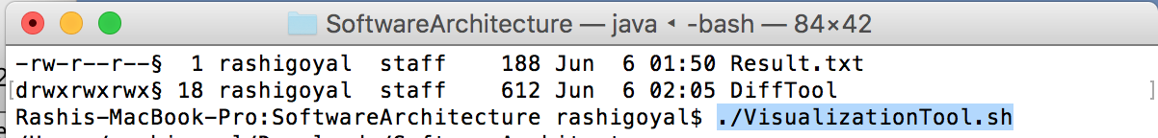

* + The output on console will appear as shown in the below screenshot (Note: The whole program will take few seconds to run)

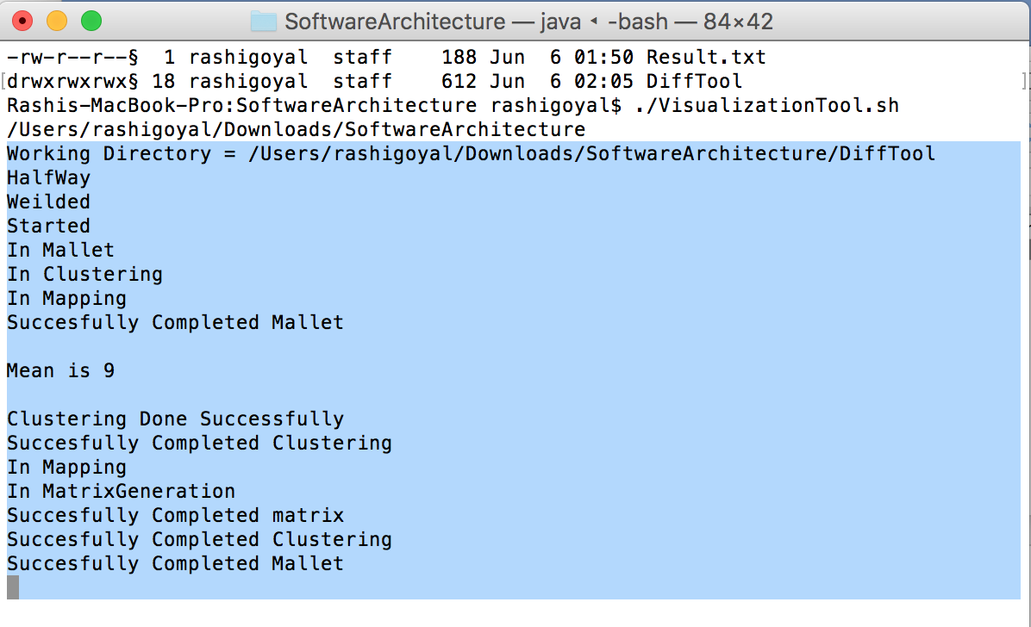

* + Another window will open with the results of final Difference Finder component. Please see the below screenshot for reference.

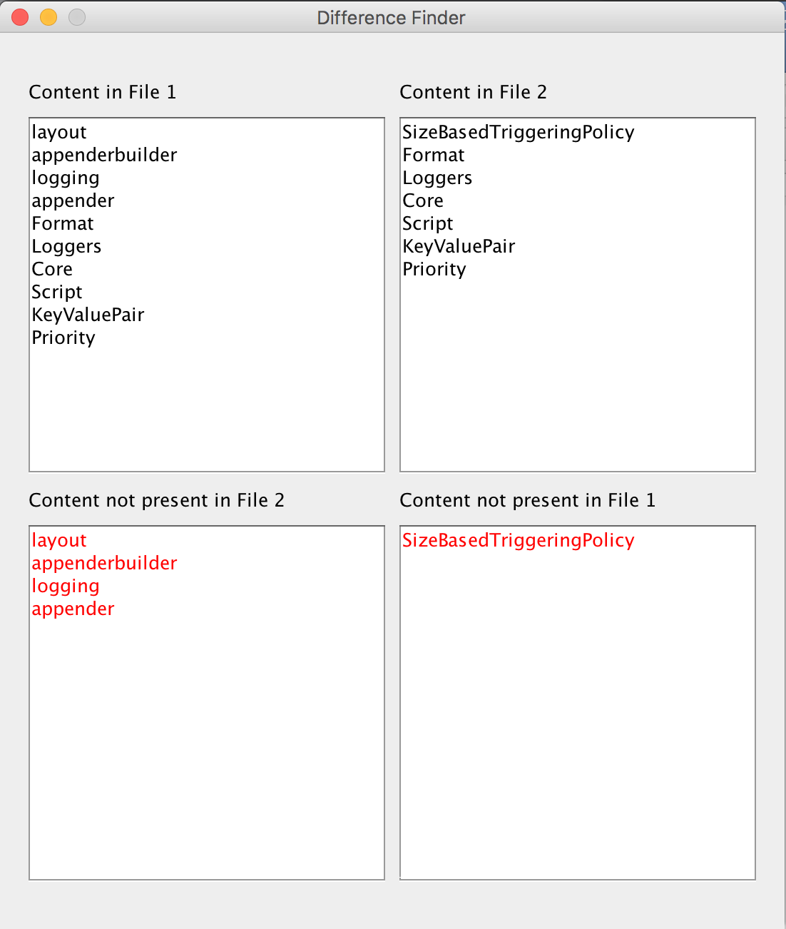

* **For Windows**
  + Open Command Prompt
  + Type in the following command

cd “<File Path>”

where File Path will be the location of the folder after opening the extracted SoftwareArchitecture.zip. Please see below screenshot for reference. (Note: Please enter the file path in double codes)

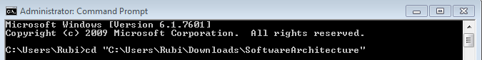

* + The cursor should be inside the extracted folder i.e. SoftwareArchitecture. Please see bellow screenshot for reference.

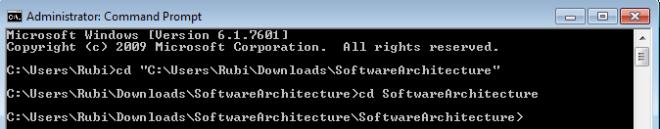

* + Now please run the below command

VisualizationTool.bat

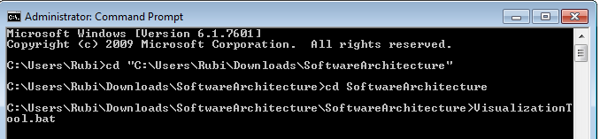

* + The output on console will appear as shown in the below screenshot (Note: The whole program will take few seconds to run)

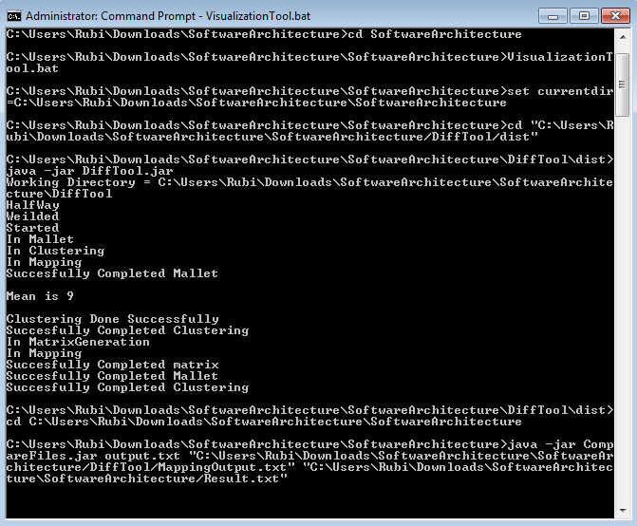

* + Another window will open with the results of final Difference Finder component. Please see the below screenshot for reference.

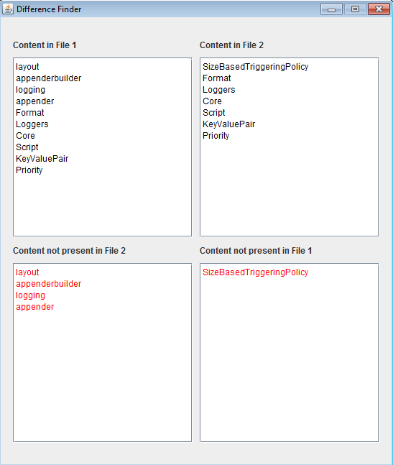

## Steps in case Executables does not run

* The first foremost important part is to give at the correct File Path in Terminal/Command prompt. The main goal here is to reach to the folder which as VisualizationTool.sh and VisualizationTool.bat files in it.

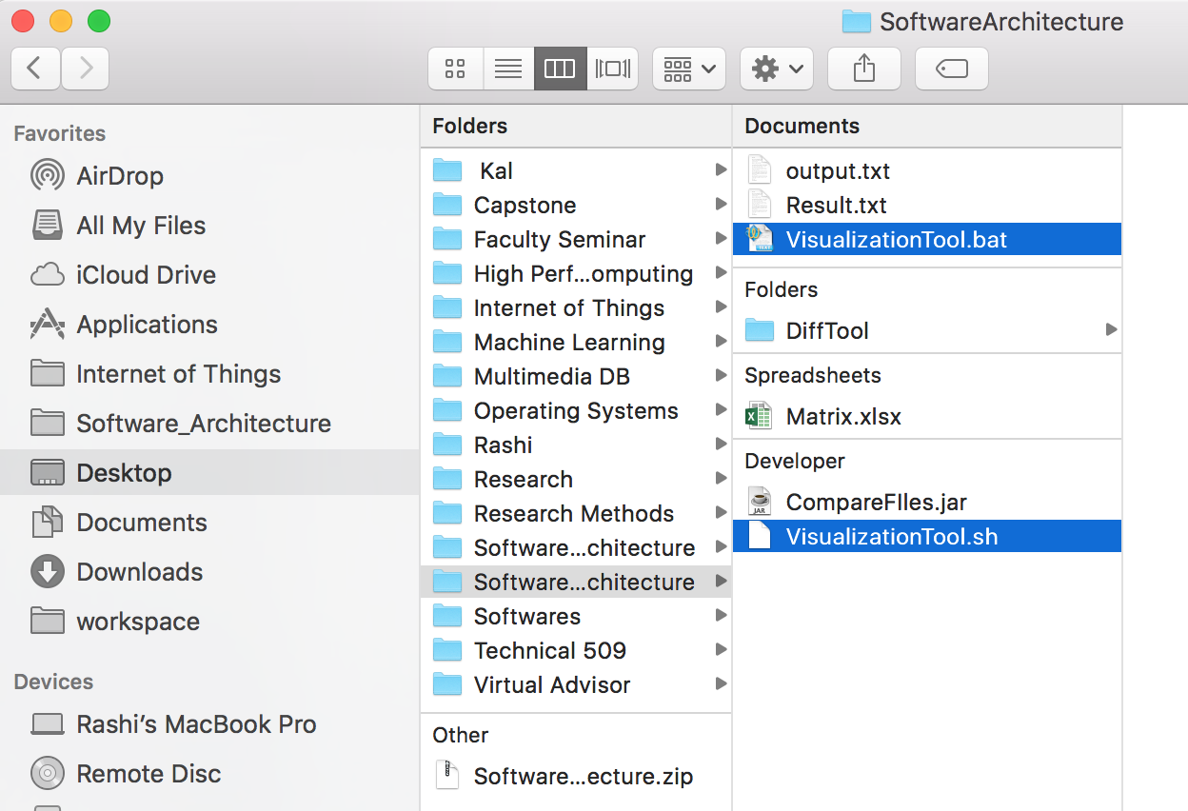

* While running the .bat file in windows Command Prompt, if the command VisualizationTool.bat does not work, then try with command VisualizationTool.

## Step by Step Walkthrough the code:

* Download the DiffTool.zip folder on your desktop.
* Extract all files from the zip folder into the Netbeans Project folder under Documents directory.
* Open Netbeans 8.1 IDE and click on the file option to open the project folder from the ‘open project’ option and Select SoftwareArchitecture folder under SoftwareArchitecture.
* There will be a DiffTool folder. Select that folder and the project files will be automatically uploaded in the NetBeans IDE.
* Click on the play button in the toolbar. On doing so, the program generates a list of print statements that verify the working and communication between all components in the C2 architecture.
* After all the c2 communication between components is completed between MatrixGenerator, Clustering and mapping components a popup window will we shown displaying the final difference output on the screen showing two files to be compared in different windows and their differences in third and fourth windows as shown in figure below.
* The output of Matrix component looks like below screenshot



* All the intermediate results are stored in DiffTool folder which is inside the extracted Software Architecture Folder. The Output files are Matrix.xslx, MappingOutput.txt, ClusteringOutput.txt and final difference finder output will be generated on final screen. Please see below screenshot for reference.

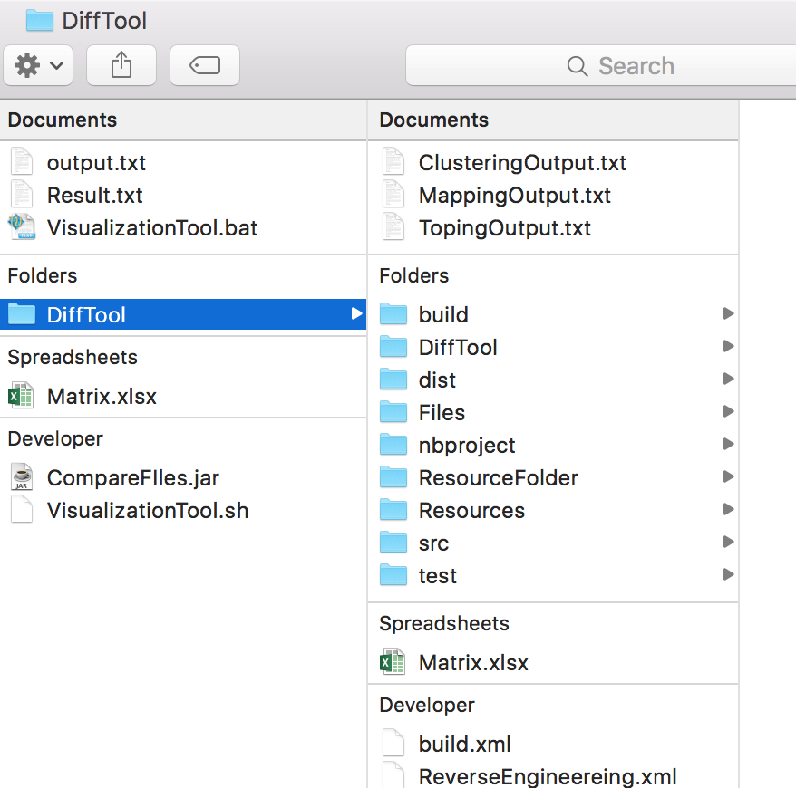

# FUTURE RELEASE

## Functional Requirements that will be included in future Release

* **Topic Modelling**
  + Currently, the system is taking the input for mapping from an Off the Shelf Tool Mallet.
  + The system is not integrated with tool. It is just taking output of Topic Modelling done by Mallet as Input for the Mapping Component.
  + To implement this functionality, a new component for Topic Modelling will be implemented and integrated with the current system.
  + There will be a change in components like Mapping and methods like topOutDataStorage.
* **UML Generator**
  + The system is taking the input for XML Parser from an Off the Shelf Tool EasyUML.
  + The system is not integrated with tool. XML Parser Component is dependent on the output of this component so we use EasyUML plugin in NetBeans IDE to generate a UML diagram in form of CDG file.
  + To implement this functionality, a new component for UML Generator will be implemented and integrated with the current system.
  + There will be a change in components like XML Parser and methods like getUMLFile
* **XML Parser**
  + The component matrix generator requires the input to be in XML format.
  + The output from Off the Shelf Tool EasyUML is in CDG format which is not supported by the Matrix Generator component.
  + The system therefore uses another OTS Tool to parse CDG file to an XML file called Notepad++.
  + To implement this functionality, a new component for XMLParser will be implemented in the UML Generator component and integrated with the current system.
  + The final output of the UML Generator tool will then be in XML file format.
  + Components like UML Generator and Mapping will be modified.

## Non-Functional Requirement that will be included in future Release

* **Performance Improvement**
  + In the future release, as the whole end to end system will be integrated and Topic Modelling will also be implemented, there will be a lot of scope to implement Multithreading.
  + Multithreading will improve the performance of the system by delegating the data flow among different components and processors.
* **Multilanguage Support**
  + The current release contains EasyUML plug in which generates the UML diagram for Java Based system.
  + In future, the system will include more plugins so that it is versatile enough to accommodate other languages.

# REFLECTION

* Architecture style can be changed at the implementation stage according to our requirement.
* Need to do research about the off-the-shelf tool before designing the software.
* Implementation of different architecture styles according to our functional and non-functional requirements.
* It is important to decide the Connector type that suits to an Architecture Style.
* Enough time is required to be dedicated for the Architecture Design.
* Designing architecture of a new project according to requirements.
* Architecture can be changed at the implementation stage according to our requirement.